COMP7024 Programming for Data Science Assignment : Data-Driven Analytics for a UK-Based Online Retailer
Namesh Panneer Selvan (22148363)
2026-03-10

Declaration
By including this statement, we the authors of this work, verify that:
- We hold a copy of this assignment that we can produce if the original is lost or damaged.
- We hereby certify that no part of this assignment/product has been copied from any other student’s work or from any other source except where due acknowledgement is made in the assignment.
- No part of this assignment/product has been written/produced for us by another person except where such collaboration has been authorised by the subject lecturer/ tutor concerned.
- We are aware that this work may be reproduced and submitted to plagiarism detection software programs for the purpose of detecting possible plagiarism (which may retain a copy on its database for future plagiarism checking).
- We hereby certify that we have read and understand what the School of Computing, Engineering and Mathematics defines as minor and substantial breaches of misconduct as outlined in the learning guide for this unit.

Introduction
The report highlights a data-driven analysis for a UK-based online retailer using transaction and product information datasets. The study is structured around four key areas: product revenue performance, identification of high-value customers, global market trends across countries, and monthly sales patterns over time. As outlined in the assessment guidelines, cancelled transactions are excluded where invoice number begins with “C”, revenue is calculated as [Quantity * UnitPrice], and product descriptions are merged into the transaction dataset using StockCode. The analysis is conducted in R using reproducible code and version control practices through Git.

Data Loading
# Load data ("project_orders" & "project_product_info")
orders <- read.csv("project_orders.csv")
products <- read.csv("project_product_info.csv")
# Quick checks of the data
head(orders)
## InvoiceNo StockCode Quantity InvoiceDate UnitPrice CustomerID
## 1 536365 85123A 6 1/12/2010 8:26 2.55 17850
## 2 536365 71053 6 1/12/2010 8:26 3.39 17850
## 3 536365 84406B 8 1/12/2010 8:26 2.75 17850
## 4 536365 84029G 6 1/12/2010 8:26 3.39 17850
## 5 536365 84029E 6 1/12/2010 8:26 3.39 17850
## 6 536365 22752 2 1/12/2010 8:26 7.65 17850
## Country
## 1 United Kingdom
## 2 United Kingdom
## 3 United Kingdom
## 4 United Kingdom
## 5 United Kingdom
## 6 United Kingdom
head(products)
## StockCode Description
## 1 85123A WHITE HANGING HEART T-LIGHT HOLDER
## 2 71053 WHITE METAL LANTERN
## 3 84406B CREAM CUPID HEARTS COAT HANGER
## 4 84029G KNITTED UNION FLAG HOT WATER BOTTLE
## 5 84029E RED WOOLLY HOTTIE WHITE HEART.
## 6 22752 SET 7 BABUSHKA NESTING BOXES
str(orders)
## 'data.frame': 541909 obs. of 7 variables:
## $ InvoiceNo : chr "536365" "536365" "536365" "536365" ...
## $ StockCode : chr "85123A" "71053" "84406B" "84029G" ...
## $ Quantity : int 6 6 8 6 6 2 6 6 6 32 ...
## $ InvoiceDate: chr "1/12/2010 8:26" "1/12/2010 8:26" "1/12/2010 8:26" "1/12/2010 8:26" ...
## $ UnitPrice : num 2.55 3.39 2.75 3.39 3.39 7.65 4.25 1.85 1.85 1.69 ...
## $ CustomerID : int 17850 17850 17850 17850 17850 17850 17850 17850 17850 13047 ...
## $ Country : chr "United Kingdom" "United Kingdom" "United Kingdom" "United Kingdom" ...
str(products)
## 'data.frame': 4070 obs. of 2 variables:
## $ StockCode : chr "85123A" "71053" "84406B" "84029G" ...
## $ Description: chr "WHITE HANGING HEART T-LIGHT HOLDER" "WHITE METAL LANTERN" "CREAM CUPID HEARTS COAT HANGER" "KNITTED UNION FLAG HOT WATER BOTTLE" ...

Data Preparation
# Remove cancelled transactions where InvoiceNo starts with "C"
library(tidyverse)
library(knitr)
orders_clean <- orders %>%
filter(!startsWith(InvoiceNo, "C"))
# Check rows removed
nrow(orders)
## [1] 541909
nrow(orders_clean)
## [1] 532621
# Join product descriptions into the orders table using StockCode and create revenue variable
retail_data <- orders_clean %>%
left_join(products, by = "StockCode") %>%
mutate(
Revenue = Quantity * UnitPrice
)
head(retail_data)
## InvoiceNo StockCode Quantity InvoiceDate UnitPrice CustomerID
## 1 536365 85123A 6 1/12/2010 8:26 2.55 17850
## 2 536365 71053 6 1/12/2010 8:26 3.39 17850
## 3 536365 84406B 8 1/12/2010 8:26 2.75 17850
## 4 536365 84029G 6 1/12/2010 8:26 3.39 17850
## 5 536365 84029E 6 1/12/2010 8:26 3.39 17850
## 6 536365 22752 2 1/12/2010 8:26 7.65 17850
## Country Description Revenue
## 1 United Kingdom WHITE HANGING HEART T-LIGHT HOLDER 15.30
## 2 United Kingdom WHITE METAL LANTERN 20.34
## 3 United Kingdom CREAM CUPID HEARTS COAT HANGER 22.00
## 4 United Kingdom KNITTED UNION FLAG HOT WATER BOTTLE 20.34
## 5 United Kingdom RED WOOLLY HOTTIE WHITE HEART. 20.34
## 6 United Kingdom SET 7 BABUSHKA NESTING BOXES 15.30
# Convert InvoiceDate to date format
retail_data$InvoiceDate <- as.POSIXct(
retail_data$InvoiceDate,
format="%d/%m/%Y %H:%M"
)
str(retail_data$InvoiceDate)
## POSIXct[1:532621], format: "2010-12-01 08:26:00" "2010-12-01 08:26:00" "2010-12-01 08:26:00" ...
# Check the joined and cleaned dataset
head(retail_data)
## InvoiceNo StockCode Quantity InvoiceDate UnitPrice CustomerID
## 1 536365 85123A 6 2010-12-01 08:26:00 2.55 17850
## 2 536365 71053 6 2010-12-01 08:26:00 3.39 17850
## 3 536365 84406B 8 2010-12-01 08:26:00 2.75 17850
## 4 536365 84029G 6 2010-12-01 08:26:00 3.39 17850
## 5 536365 84029E 6 2010-12-01 08:26:00 3.39 17850
## 6 536365 22752 2 2010-12-01 08:26:00 7.65 17850
## Country Description Revenue
## 1 United Kingdom WHITE HANGING HEART T-LIGHT HOLDER 15.30
## 2 United Kingdom WHITE METAL LANTERN 20.34
## 3 United Kingdom CREAM CUPID HEARTS COAT HANGER 22.00
## 4 United Kingdom KNITTED UNION FLAG HOT WATER BOTTLE 20.34
## 5 United Kingdom RED WOOLLY HOTTIE WHITE HEART. 20.34
## 6 United Kingdom SET 7 BABUSHKA NESTING BOXES 15.30
summary(retail_data$Revenue)
## Min. 1st Qu. Median Mean 3rd Qu. Max.
## -11062.06 3.75 9.90 19.99 17.70 168469.60
# Data quality check
sum(is.na(retail_data$Description))
## [1] 0
sum(is.na(retail_data$CustomerID))
## [1] 134697
sum(duplicated(products$StockCode))
## [1] 0

Comments on data preparation
Even after removing cancelled invoices, the cleaned dataset still has some negative revenue values (-11062.06), likely due to returned items or credit adjustments not captured solely by the invoice prefix rule.

Analytical Task Description
The following section presents a detailed analysis provided using R on the transactional data from the UK-based online retailer. As mentioned in the introduction of the report the analysis is focused around evaluating the product performance, customer behaviour, global sales patterns and monthly revenue trends using analytical methods.

Question 1: Product Revenue Analysis

Explanation
The task focuses on analysing the performance of the product by calculating the total revenue generate by each product. The product of quantity and unit price for each transaction is the total revenue generated.The highest and lowest performing product is determined by aggregating revenues at product level.

Code
# Total revenue calculation at product level
product_revenue <- retail_data %>%
group_by(StockCode, Description) %>%
summarise(
TotalRevenue = sum(Revenue, na.rm = TRUE),
.groups = "drop"
) %>%
arrange(desc(TotalRevenue))
# Top 10 highest revenue products
top10_products <- product_revenue %>%
slice_max(order_by = TotalRevenue, n = 10, with_ties = FALSE)
# Bottom 10 lowest revenue products
bottom10_products <- product_revenue %>%
slice_min(order_by = TotalRevenue, n = 10, with_ties = FALSE)
# Top 3 products
top3_products <- product_revenue %>%
slice_max(order_by = TotalRevenue, n = 3)
# Contribution by top 3 products
total_revenue_all <- sum(product_revenue$TotalRevenue)
top3_contribution <- top3_products %>%
summarise(
Top3Revenue = sum(TotalRevenue),
ContributionPercent = (sum(TotalRevenue) / total_revenue_all) * 100
)
# Display results
top10_products
## # A tibble: 10 × 3
## StockCode Description TotalRevenue
## <chr> <chr> <dbl>
## 1 DOT DOTCOM POSTAGE 206249.
## 2 22423 REGENCY CAKESTAND 3 TIER 174485.
## 3 23843 PAPER CRAFT , LITTLE BIRDIE 168470.
## 4 85123A WHITE HANGING HEART T-LIGHT HOLDER 104519.
## 5 47566 PARTY BUNTING 99504.
## 6 85099B JUMBO BAG RED RETROSPOT 94340.
## 7 23166 MEDIUM CERAMIC TOP STORAGE JAR 81701.
## 8 M Manual 78110.
## 9 POST POSTAGE 78102.
## 10 23084 RABBIT NIGHT LIGHT 66965.
bottom10_products
## # A tibble: 10 × 3
## StockCode Description TotalRevenue
## <chr> <chr> <dbl>
## 1 B "Adjust bad debt" -11062.
## 2 10123G "" 0
## 3 10134 "" 0
## 4 16053 "" 0
## 5 17011A "" 0
## 6 20689 "" 0
## 7 20738 "" 0
## 8 20825 "" 0
## 9 20849 "" 0
## 10 20850 "" 0
top3_products
## # A tibble: 3 × 3
## StockCode Description TotalRevenue
## <chr> <chr> <dbl>
## 1 DOT DOTCOM POSTAGE 206249.
## 2 22423 REGENCY CAKESTAND 3 TIER 174485.
## 3 23843 PAPER CRAFT , LITTLE BIRDIE 168470.
top3_contribution
## # A tibble: 1 × 2
## Top3Revenue ContributionPercent
## <dbl> <dbl>
## 1 549203. 5.16

Visualisation
# Top 10 products by revenue
ggplot(top10_products,
aes(x = reorder(Description, TotalRevenue),
y = TotalRevenue)) +
geom_col(fill = "lightblue") +
coord_flip() +
labs(
title = "Top 10 Products by Revenue",
x = "Product Description",
y = "Total Revenue"
)
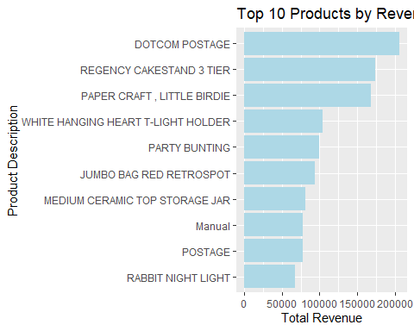
# Bottom 10 products by revenue
ggplot(bottom10_products,
aes(x = reorder(Description, TotalRevenue),
y = TotalRevenue)) +
geom_col(fill = "orange") +
coord_flip() +
labs(
title = "Bottom 10 Products by Revenue",
x = "Product Description",
y = "Total Revenue"
)
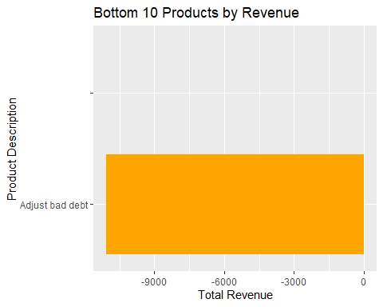
# Revenue share of top product
top10_products <- top10_products %>%
mutate(
Share = (TotalRevenue / total_revenue_all) * 100
)
ggplot(top10_products,
aes(x = reorder(Description, Share),
y = Share)) +
geom_col(fill = "lightgreen") +
coord_flip() +
labs(
title = "Revenue Share of Top Products",
x = "Product",
y = "Percentage of Total Revenue"
)
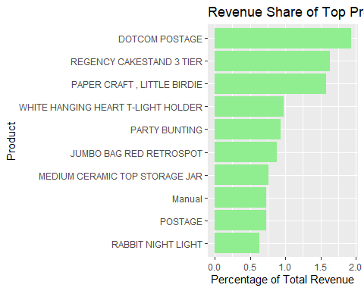

Interpretation
The product revenue analysis suggests that an important share of retailer’s total revenue is generated via small group of products. Whereas the top performing products are major contributors towards overall sales, suggesting a strong demand and consistent purchasing patterns. However, certain products generate very low revenue, suggesting limited demand or low purchase frequency. Based on the above highlighted findings it is important to focus on high-performing products while reviewing low-performing items for better product pricing, promotion and inventory management.

Question 2: High-Value Customer Analysis

Explanation
The task requires to identify the highest-value customers based on their total spending capacity.The total revenue generated from the overall transactions associated with each customer is considered as customer spending.Analysing top customer purchasing pattern for understanding their purchasing behavior.

Code
# Total spending by customer
customer_spending <- retail_data %>%
filter(!is.na(CustomerID)) %>%
group_by(CustomerID) %>%
summarise(
TotalSpending = sum(Revenue, na.rm = TRUE),
.groups = "drop"
) %>%
arrange(desc(TotalSpending))
# Top 5 highest-spending customers
top5_customers <- customer_spending %>%
slice_max(order_by = TotalSpending, n = 5, with_ties = FALSE)
top5_customers
## # A tibble: 5 × 2
## CustomerID TotalSpending
## <int> <dbl>
## 1 14646 280206.
## 2 18102 259657.
## 3 17450 194551.
## 4 16446 168472.
## 5 14911 143825.
# Products purchased by top customers
top_customer_products <- retail_data %>%
filter(CustomerID %in% top5_customers$CustomerID) %>%
filter(!is.na(Description)) %>%
group_by(CustomerID, Description) %>%
summarise(
TotalQuantity = sum(Quantity, na.rm = TRUE),
.groups = "drop"
) %>%
arrange(CustomerID, desc(TotalQuantity))
top_customer_products
## # A tibble: 2,753 × 3
## CustomerID Description TotalQuantity
## <int> <chr> <int>
## 1 14646 "RABBIT NIGHT LIGHT" 4801
## 2 14646 "SPACEBOY LUNCH BOX " 4492
## 3 14646 "PACK OF 72 RETROSPOT CAKE CASES" 4104
## 4 14646 "DOLLY GIRL LUNCH BOX" 4096
## 5 14646 "ROUND SNACK BOXES SET OF4 WOODLAND " 3120
## 6 14646 "RED TOADSTOOL LED NIGHT LIGHT" 2376
## 7 14646 "WOODLAND CHARLOTTE BAG" 2300
## 8 14646 "RED RETROSPOT CHARLOTTE BAG" 2100
## 9 14646 "5 HOOK HANGER RED MAGIC TOADSTOOL" 2016
## 10 14646 "JUMBO BAG RED RETROSPOT" 2000
## # ℹ 2,743 more rows

Visualisation
ggplot(top5_customers,
aes(x = factor(CustomerID),
y = TotalSpending)) +
geom_col(fill = "steelblue") +
labs(
title = "Top 5 Highest-Spending Customers",
x = "Customer ID",
y = "Total Spending"
) +
theme_minimal()
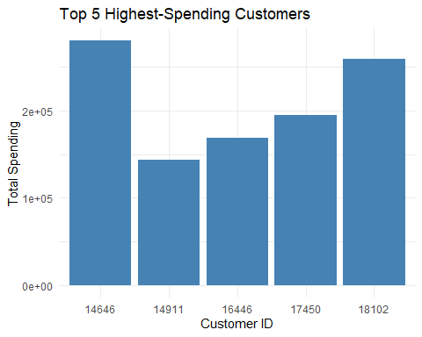

Interpretation
The analysis highlights the spending power of top 5 customer who are the major contributors towards the retailer’s total revenue.The sales performance is highly influenced by these customers who represent a valuable segment in their business.The understanding of their purchase behavior can help in making better sales strategy.

Question 3: Global Market Analysis

Explanation
The Task requires to perform an analysis showing the sales performance of different countries based on total revenue calculated from the retailer’s transaction data.The main objective is to identify the highest-revenue countries and examine the most purchased product in each country for better understanding country-level sales pattern and product demand.

Code
# Total revenue by country
country_revenue <- retail_data %>%
group_by(Country) %>%
summarise(
TotalRevenue = sum(Revenue, na.rm = TRUE),
.groups = "drop"
) %>%
arrange(desc(TotalRevenue))
country_revenue
## # A tibble: 38 × 2
## Country TotalRevenue
## <chr> <dbl>
## 1 United Kingdom 9003098.
## 2 Netherlands 285446.
## 3 EIRE 283454.
## 4 Germany 228867.
## 5 France 209715.
## 6 Australia 138521.
## 7 Spain 61577.
## 8 Switzerland 57090.
## 9 Belgium 41196.
## 10 Sweden 38378.
## # ℹ 28 more rows
# Top product by quantity in each country
country_top_product <- retail_data %>%
filter(!is.na(Description)) %>%
group_by(Country, StockCode, Description) %>%
summarise(
TotalQuantity = sum(Quantity, na.rm = TRUE),
.groups = "drop"
) %>%
group_by(Country) %>%
slice_max(order_by = TotalQuantity, n = 1, with_ties = FALSE) %>%
ungroup()
country_top_product
## # A tibble: 38 × 4
## Country StockCode Description TotalQuantity
## <chr> <chr> <chr> <int>
## 1 Australia 22492 "MINI PAINT SET VINTAGE " 2952
## 2 Austria 21918 "SET 12 KIDS COLOUR CHALK STICKS" 288
## 3 Bahrain 23076 "ICE CREAM SUNDAE LIP GLOSS" 96
## 4 Belgium 21212 "PACK OF 72 RETROSPOT CAKE CASES" 480
## 5 Brazil 21430 "SET/3 RED GINGHAM ROSE STORAGE BOX" 24
## 6 Canada 37370 "RETRO COFFEE MUGS ASSORTED" 504
## 7 Channel Islands 21785 "RAIN PONCHO " 407
## 8 Cyprus 22335 "HEART DECORATION PAINTED ZINC " 384
## 9 Czech Republic 22578 "WOODEN STAR CHRISTMAS SCANDINAVIAN" 72
## 10 Denmark 21915 "RED HARMONICA IN BOX " 288
## # ℹ 28 more rows
# Summary
country_summary <- country_revenue %>%
left_join(country_top_product, by = "Country")
country_summary
## # A tibble: 38 × 5
## Country TotalRevenue StockCode Description TotalQuantity
## <chr> <dbl> <chr> <chr> <int>
## 1 United Kingdom 9003098. 23843 "PAPER CRAFT , LITTLE BI… 80995
## 2 Netherlands 285446. 23084 "RABBIT NIGHT LIGHT" 4801
## 3 EIRE 283454. 22197 "SMALL POPCORN HOLDER" 1852
## 4 Germany 228867. 22326 "ROUND SNACK BOXES SET O… 1233
## 5 France 209715. 23084 "RABBIT NIGHT LIGHT" 4024
## 6 Australia 138521. 22492 "MINI PAINT SET VINTAGE " 2952
## 7 Spain 61577. 84997D "PINK 3 PIECE POLKADOT C… 1089
## 8 Switzerland 57090. 22554 "PLASTERS IN TIN WOODLAN… 639
## 9 Belgium 41196. 21212 "PACK OF 72 RETROSPOT CA… 480
## 10 Sweden 38378. 22492 "MINI PAINT SET VINTAGE " 2916
## # ℹ 28 more rows

Visualisation
# Top 10 countries by revenue
top10_countries <- country_revenue %>%
slice_max(order_by = TotalRevenue, n = 10, with_ties = FALSE)
ggplot(top10_countries,
aes(x = reorder(Country, TotalRevenue),
y = TotalRevenue)) +
geom_col(fill = "skyblue") +
coord_flip() +
labs(
title = "Top 10 Countries by Revenue",
x = "Country",
y = "Total Revenue"
) +
theme_minimal()
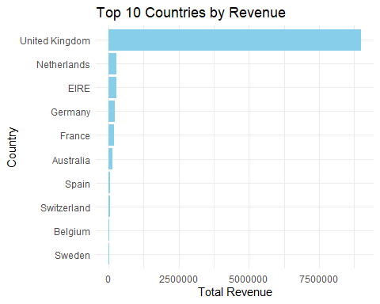

Interpretation
The results for country level analysis demonstrates that United Kingdom records the highest total revenue, followed by other countries like Netherlands, EIRE, Germany and France, indicating a strong retail sales in major international countries. It is also noticed that product purchase varies across countries, highlighting difference in customer preferences and buying pattern.These findings clearly suggests that it is important to adopt country specific sales and marketing strategies rather than relying on a single global approach.

Question 4: Temporal Analysis & Trends

Explanation
The task focuses on the retailer’s revenue over time by analysing total revenue for each month and identify the months with highest sales. It also require identify certain products that repeatedly appear among the lowest performing products across these months.This helps to understand the seasonal sales pattern and consistently weak performing products.

Code
# Create year-month variable
retail_data <- retail_data %>%
mutate(
YearMonth = format(InvoiceDate, "%Y-%m")
)
# Monthly revenue summary
monthly_revenue <- retail_data %>%
group_by(YearMonth) %>%
summarise(
TotalRevenue = sum(Revenue, na.rm = TRUE),
.groups = "drop"
) %>%
arrange(YearMonth)
monthly_revenue
## # A tibble: 13 × 2
## YearMonth TotalRevenue
## <chr> <dbl>
## 1 2010-12 823746.
## 2 2011-01 691365.
## 3 2011-02 523632.
## 4 2011-03 717639.
## 5 2011-04 537809.
## 6 2011-05 770536.
## 7 2011-06 761740.
## 8 2011-07 719221.
## 9 2011-08 737014.
## 10 2011-09 1058590.
## 11 2011-10 1154979.
## 12 2011-11 1509496.
## 13 2011-12 638793.
# Highest revenue month
highest_revenue_month <- monthly_revenue %>%
slice_max(order_by = TotalRevenue, n = 1, with_ties = FALSE)
highest_revenue_month
## # A tibble: 1 × 2
## YearMonth TotalRevenue
## <chr> <dbl>
## 1 2011-11 1509496.
# Product revenue by month
monthly_product_revenue <- retail_data %>%
filter(!is.na(Description)) %>%
group_by(YearMonth, StockCode, Description) %>%
summarise(
TotalRevenue = sum(Revenue, na.rm = TRUE),
.groups = "drop"
)
# Bottom 10 products in each month
monthly_bottom10 <- monthly_product_revenue %>%
group_by(YearMonth) %>%
slice_min(order_by = TotalRevenue, n = 10, with_ties = FALSE) %>%
ungroup()
monthly_bottom10
## # A tibble: 130 × 4
## YearMonth StockCode Description TotalRevenue
## <chr> <chr> <chr> <dbl>
## 1 2010-12 20849 "" 0
## 2 2010-12 20950 "" 0
## 3 2010-12 21134 "" 0
## 4 2010-12 21414 "" 0
## 5 2010-12 21431 "" 0
## 6 2010-12 21653 "" 0
## 7 2010-12 21661 "" 0
## 8 2010-12 21763 "" 0
## 9 2010-12 22353 "LUNCH BOX WITH CUTLERY FAIRY CAKES " 0
## 10 2010-12 35951 "" 0
## # ℹ 120 more rows
# Products repeatedly appearing in monthly bottom 10
recurring_low_products <- monthly_bottom10 %>%
group_by(StockCode, Description) %>%
summarise(
MonthsInBottom10 = n(),
.groups = "drop"
) %>%
arrange(desc(MonthsInBottom10))
recurring_low_products
## # A tibble: 125 × 3
## StockCode Description MonthsInBottom10
## <chr> <chr> <int>
## 1 16207B "PINK HEART RED HANDBAG" 2
## 2 20701 "PINK CAT FLORAL CUSHION COVER " 2
## 3 21147 "JINGLE BELLS TREE DECORATION" 2
## 4 22689 "DOORMAT MERRY CHRISTMAS RED " 2
## 5 22925 "BLUE GIANT GARDEN THERMOMETER" 2
## 6 10123C "HEARTS WRAPPING TAPE " 1
## 7 10123G "" 1
## 8 10133 "COLOURING PENCILS BROWN TUBE" 1
## 9 10134 "" 1
## 10 16010 "FOLDING CAMPING SCISSOR W/KNIF & S" 1
## # ℹ 115 more rows

Visualisation
# Monthly revenue trend
ggplot(monthly_revenue,
aes(x = YearMonth, y = TotalRevenue, group = 1)) +
geom_line(color = "steelblue", linewidth = 1) +
geom_point(color = "darkblue") +
labs(
title = "Monthly Revenue Trend",
x = "Year-Month",
y = "Total Revenue"
) +
theme_minimal() +
theme(axis.text.x = element_text(angle = 45, hjust = 1))
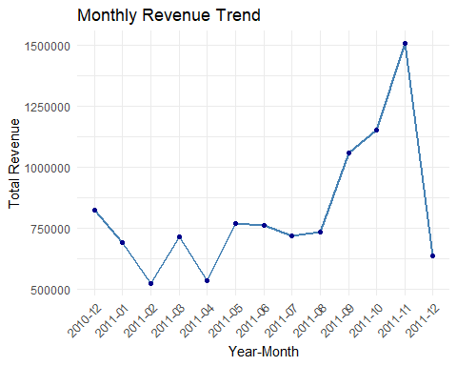

Interpretation
Based on the above visual analysis there is a gradual increase in the monthly revenue during the year 2011, with November reporting the highest. The analysis suggests a pattern of seasonality, with strong sales towards the end of the year. It also suggests that low performing products appeared more than once in the bottom 10 which indicates an inconsistency in demand over time. This clearly suggest that the retailer should have an inventory plan based around the peak period in their sales pattern while parallelly reviewing low performing products for discontinuation or repricing.

Report Conclusion
The report highlights key analysis of the insights from the UK-based retailer’s transactional data.The analysis on product revenue suggests that only a small number of products are contributing to the overall sales. Customer analysis highlighted a limited number of high-value customers contribute towards the substantial revenue for the business. Strong international demand is identified through country level analysis where United Kingdom is contributing the major chunk of the company sales, supported by countries like Netherlands, EIRE, Germany and France, indicating a strong retail sales in major international countries. Finally, seasonal sales pattern is identified through temporal analysis which suggest high sales towards the end of the year. These findings help understand the data and build product strategy, planning and decisions related to marketing and inventory management.

I confirm that: - I understand all code submitted. - I can explain my solution if required.

